3. Adjusting Entries: 1. Adjust A Printed Invoice

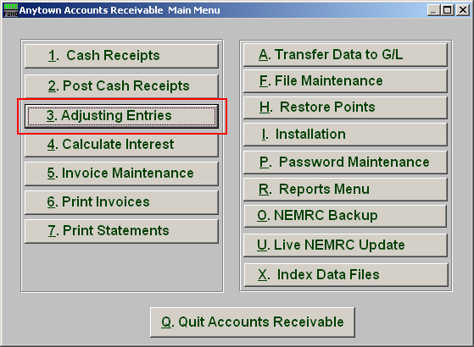
Click on “3. Adjusting Entries” from the Main Menu and the following window will appear:

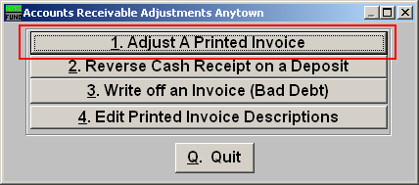
Click on “1. Adjust A Printed Invoice” from the Adjusting Entries Menu and the following window will appear:
Adjust a Printed Invoice

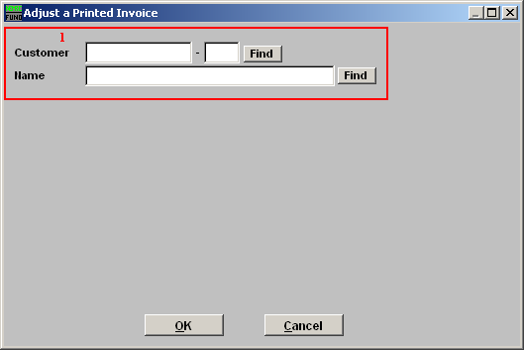
- Find: Enter the Customer number or Name or click “Find” and locate the Customer from the list.

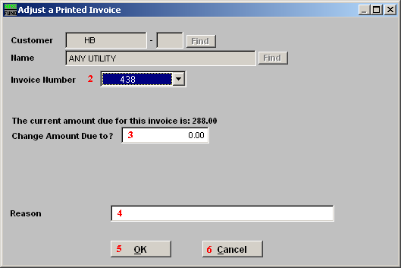
      - Invoice Number: Type in the Invoice Number or click on the drop down arrow and select from there.

      - Current Amount Due to?: Type in the amount the invoice needs to be changed to.

      - Reason: Type in the Reason for the change.

      - OK: Click “OK” to save changes and the option to View/Edit the posting will be provided. You may alter the application of the adjustment from there when needed.

      - Cancel: Click “Cancel” to cancel and return to the previous screen.

